Exercise 16
- List ids, birth dates and emails of employees born in April.
Answer: SELECT
emp_id,
birth_date,
email
FROM
employee_data
WHERE
MONTH(birth_date) = 4;

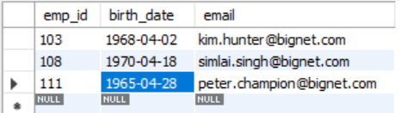

- Display Ids, birth dates and spouse names of employees born in 1969
and sort the entire records on the basis of their spouse names.
Answer: SELECT
emp_id,
birth_date,
spouse_name
FROM
employee_data
WHERE
YEAR(birth_date) = 1969
ORDER BY
spouse_name ASC;
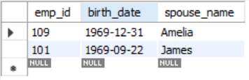
- List the employee ids for employees born under the current month.
Answer: SELECT
emp_id
FROM
employee_data
WHERE
month
MONTH(birth_date) = MONTH(CURDATE());
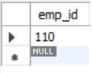

- How many unique birth years do we have?
Answer: SELECT
COUNT(DISTINCT YEAR(birth_date)) AS unique_birth_years
FROM
employee_data;
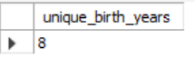

- Display a list of unique birth years and the number of employees born under each.
Answer: SELECT
YEAR(birth_date) AS birth_year,
COUNT(emp_id) AS number_of_employees
FROM
employee_data
GROUP BY
birth_year
ORDER BY
birth_year ASC;
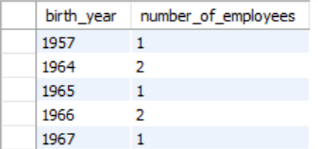

- How many employees were born under each month? The display
should have month names (NOT numbers) and the entries should be
sorted with the month having the largest number listed first.

Answer: SELECT
MONTHNAME(birth_date) AS birth_month,
COUNT(emp_id) AS employee_count
FROM
employee_data
GROUP BY
birth_month
ORDER BY
employee_count DESC,
birth_month ASC;

